14/09/20 – Monday

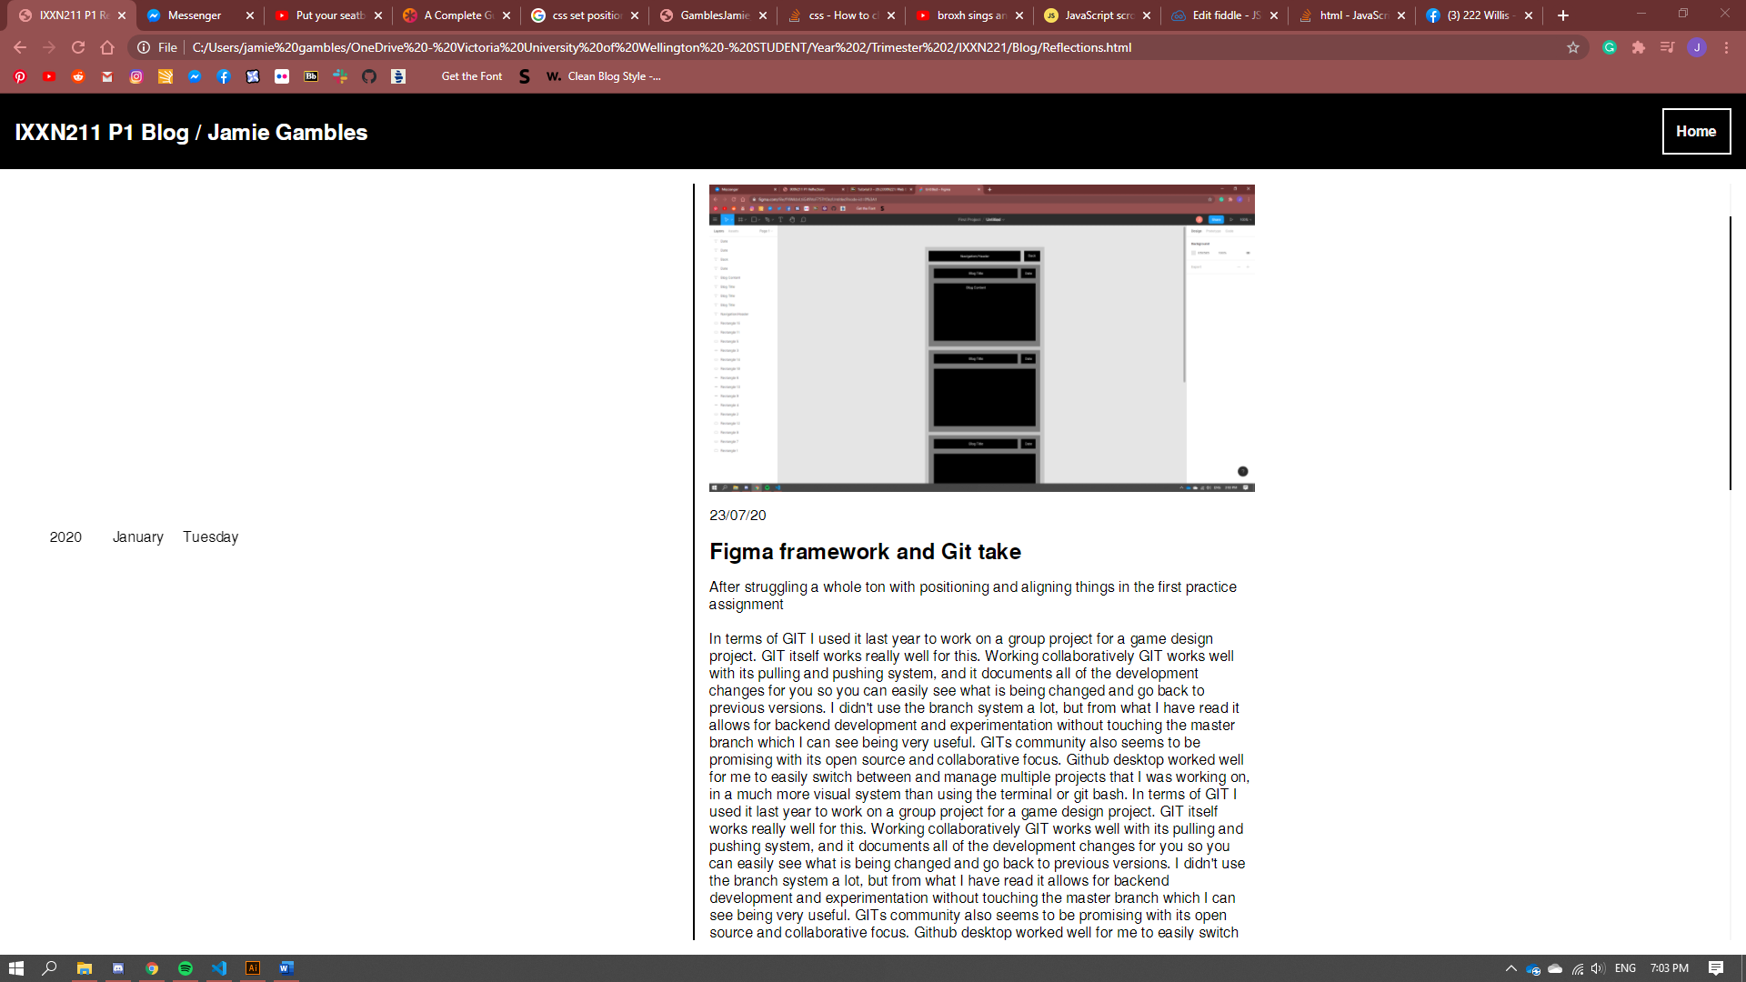

* More work on the blog, I added in a feature that I have been planning for a bit, essentially the date is show in 3 columns on the left hands side, when you scroll the elements are all sticking to the blog posts that each element is relevant to, then when you scroll past the end of a blog the new date will scroll up with it and then become stickied at the same position as the old date. This is a bit of a gimmick, but I like to think that it helps to better visualise the passing of time between each blog post.

14/09/20 – Monday

* Another discord call with the group, we each went through the wireframes that we made and discussed what was good and what we thought needed changing. We then used the wireframes we had made to start deriving a style guide.

11/09/20 - Friday

* Discord call with group, showed my prototyped block frame and assigned content to each person.

10/09/20 - Thursday

* Thursday Class work session. pitched my idea for navigating the website to group as there was a lot of inconsistencies between everyone’s block framework, and I wanted to stray away from the traditional ways of navigating a website. Based on my pitch we rearranged our user flow to line up with this idea.

8/09/20 - Tuesday

* Tuesday Class work session. We were tasked with making our block frames for the next class session. We split up the pages to be done based off the user flow that we created earlier. I opted to do the Nominations page however I found it really difficult to start designing the page without having the framework of the website really locked down. Everyone started doing their own versions of navigation bars and I really felt like before we started designing anything we should have properly sat down and came up with the general framework of the website, so that we can better design each page.

4/09/20 – Friday

* Went to Jacks and we worked with Madison through discord. I made a quick user flow/block frame in figma using the templates that Blaine selected. And Jack and Madison worked through finishing our brief and creating our mood boards.

3/09/20 – Thursday

* Thursday class session through zoom. In our groups we were supposed to have created our key users and finalized the idea of our website. We were tasked with making our user flows for the website in figma and creating our brief. We split the work up so that me and Kat worked on the user flow, whilst jack Madison and Cindy worked on finishing up the brief.

1/09/20 – Tuesday

* Our first work session in our group. We pitched our ideas for our website. I pitched two ideas, one was a simplified app that made catching a bus a lot simpler, and the other was a Pinterest board inspired site where you could take notes and drop images. Jack pitched a Chicken Nugget review website, Madison pitched a website that was an index of businesses where the user could easily navigate through and find the service that they were after. Kat pitched a website that acted as a database of work examples for Victoria university projects. After talking a bit with Josh, we chose Madison’s ideas, as Josh warned us that creating websites with databases would be difficult, and that ruled out pretty much all of the other suggestions. We then further discussed our website with Blaine, where he suggested that we narrow our scope further, and target specific businesses, from this we chose to specifically do hospitality businesses that we curated under 4 categories, cost, charity, environment, and local.

18/08/20 – Tuesday

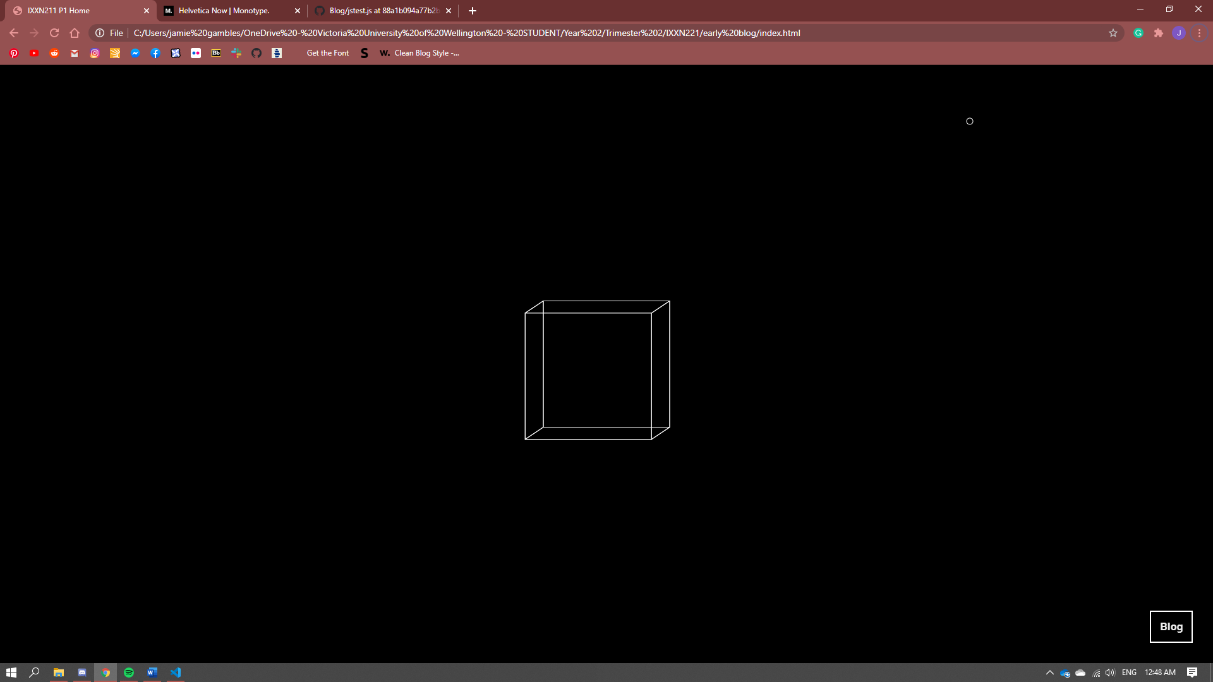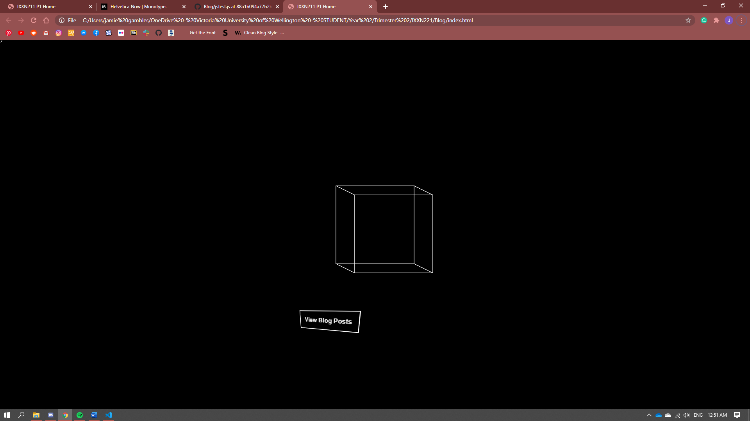

* After doing the dark mode tutorial I had an attempt at implementing p5.js into my blog because I wanted to create some nice effects to go in the background of the home page. Getting p5 seamlessly into html I found difficult, I ended up using an Iframe and linking the JavaScript in. Although I still had a lot of issues in making the iframe responsive I eventually got it working. One of the effects that I am really interested in is parallax, so I quickly created this faux 3d cube that changes perspective based on where the mouse is. I liked this effect, but I didn’t like how it was always just a background element, and I couldn’t interact with the objects I was drawing through the iframe like a pressing a button. I looked at this website through awwwards <https://activetheory.net/home> and chose to try and replicate the parallaxes button on the home page. While I don’t think that I will use this specific effect in my blog, it was a good experiment in learning how to implement more complicated use of JavaScript into websites.

17/08/20 – Monday

* Thought I would get around to finishing up the dark mode tutorial that we did in our last class on Thursday. I found this one easy using the JavaScript that was included in the example site, and then adding classes and containers around the content in the flexbox tutorial to fit. My dark mode is not the prettiest thing, but I got the hold of how this can be used fairly fast.

13/08/20 – Thursday

* Todays class I did not do a lot given it’s the last class before the mid semester holidays. We got introduced to the dark mode exercise which seems to be using a lot more JavaScript.

12/08/20 – Wednesday

* I did the exercise that was introduced on Tuesday’s class today, which was our introduction to JavaScript. We needed to make a page that had two buttons which allowed the user to switch between two static images. I decided that I would go a step farther, and make the same system with one button, that switches the image back and forth.

11/08/20 – Tuesday

* Hand in for our wireframes today. Very hectic. My time management for this project really hasn’t been the best, I had rough wireframes done for both outcomes done this morning however I really underestimated the work I needed to get done. I went to class with just my report yet to write for the hand-in at 5, however after talking to josh I found that the wireframes that I had done were too close to block frames and that I needed to work more on incorporating the styling that I wanted for each website into the wireframes. Blaine gave me an extension til midnight to hand-in which helped hugely. I finished writing the report that I had started in class, and then went about restyling a lot of the wireframe components. The main areas that I redesigned were the navbars for both the wireframes, and the ‘card’ that portrayed the information of a class. I also went about redesigning each of the interactable objects to make it clear that they could be clicked on.

10/08/20 – Monday

* I’m doing most of the ‘designing’ of the wireframes tonight. My first and in my opinion best of the two wireframe ideas is a sort of backtracking system. Where the user starts at their last year for their chosen degree, and then as they select papers for that year, the pre requisite papers that they would have needed to have taken in order to take those papers in their last year are automatically added to their previous years and a line is drawn between each of the classes. The intentions behind this design is that by the end of selecting their papers the user will have a ‘tree’ like diagram that represents the direction that they have taken each course. My other idea a lot simpler and more traditional, there is a navbar at the top which allows the user to switch between years and the select degree page. On each page for a specific year the user can drag and drop papers from a search box and into tabs for each of the trimester. As they do so their point totals and requirements will change dynamically on a tab on the same page. The intention behind both of my designs is to give a sense of tactility and weight to their selections outside of dropdown menus, and to very clearly show the prerequisite papers that need to be taken in order to complete their selected degree.

6/08/20 – Thursday

* Thursday class session, today we went through the grids exercise. I had already used grids a fair bit in my blog, so this wasn’t that new to me. I used the same media queries as in the flex box tutorial to make the grid structure change at a certain page width.

4/08/20 – Tuesday

* Tuesdays class, we looked at wireframe examples and user flows today

30/07/20 - Thursday

* Thursday Class session, we didn’t have any exercises to do today, we did a bit of a catch up on the work that we are doing for project 1. I started to familiarise myself with figma a bit more and worked out the grids tool within frames which is helping immensely with laying elements out proportionately and keeping consistent padding. I don’t know what either of my website wireframes will be just yet, but I do know that I will be going for 2nd brief option where we are tasked to create a course selection planner for the Victoria university website. At the moment I am thinking of creating a system that works backwards, where the user starts in their last year selecting papers, and then works their way back to their first year. The reason for doing it this way is so that the requirements for third year papers are made a lot clearer as they would be added to the previous year’s automatically.

28/07/20 – Tuesday

* Tuesday class session. We went through flexboxes today, for the class exercise we had to make a responsive version of a website provided to us, by using media queries to check the page width, and then change the CSS once it reaches a threshold.

26/07/20 – Sunday

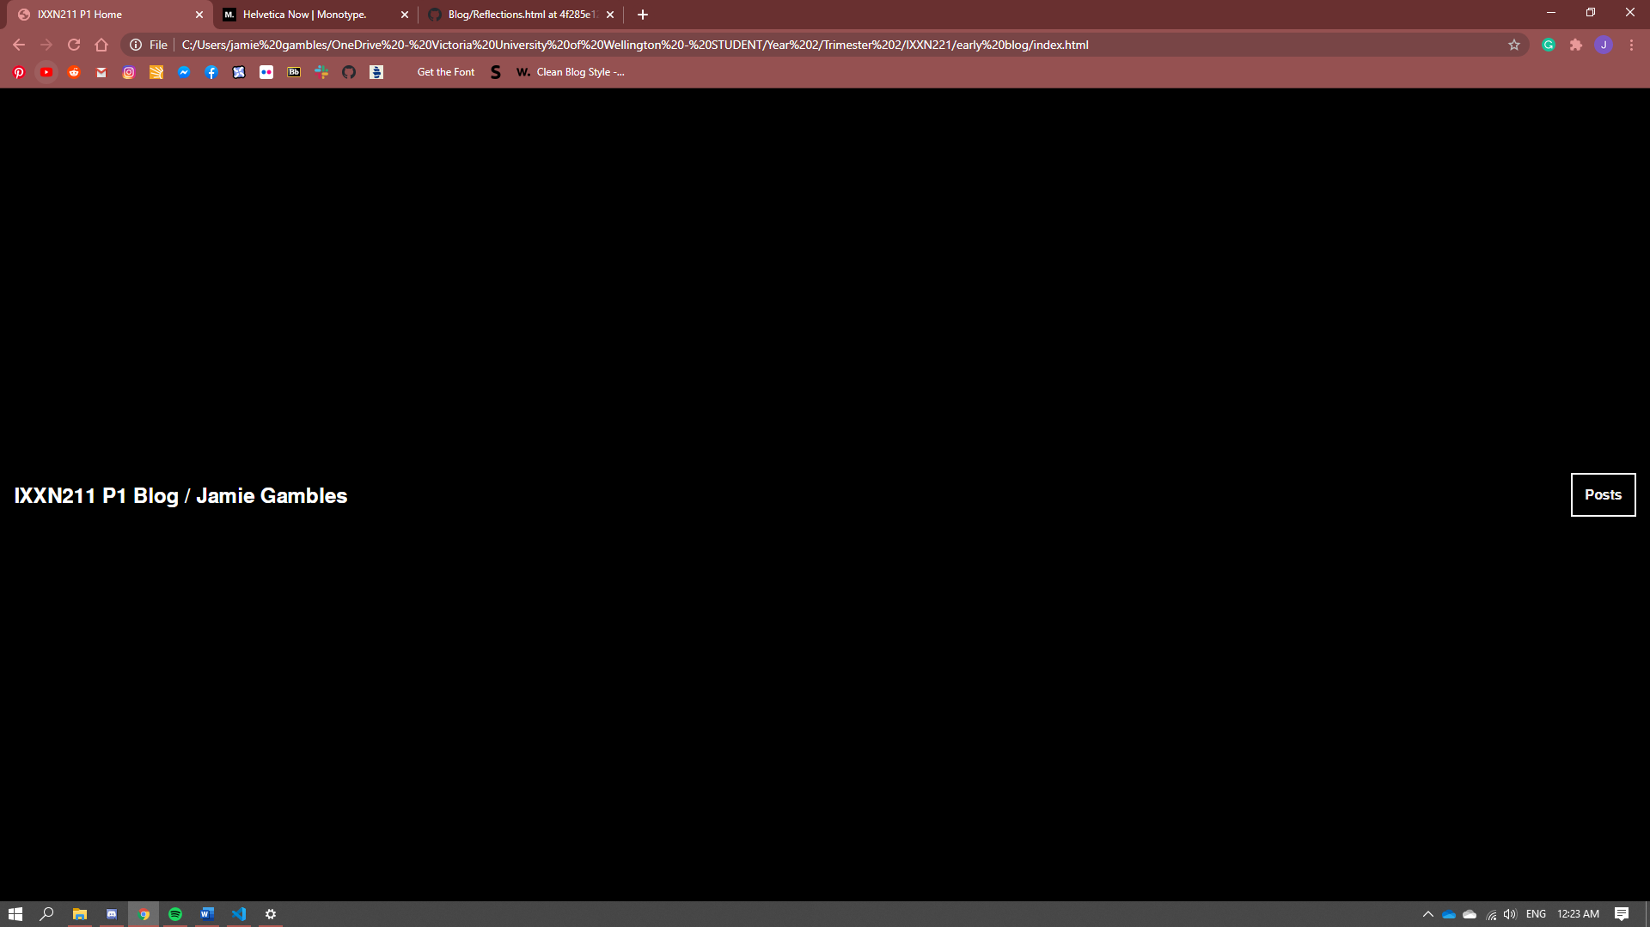

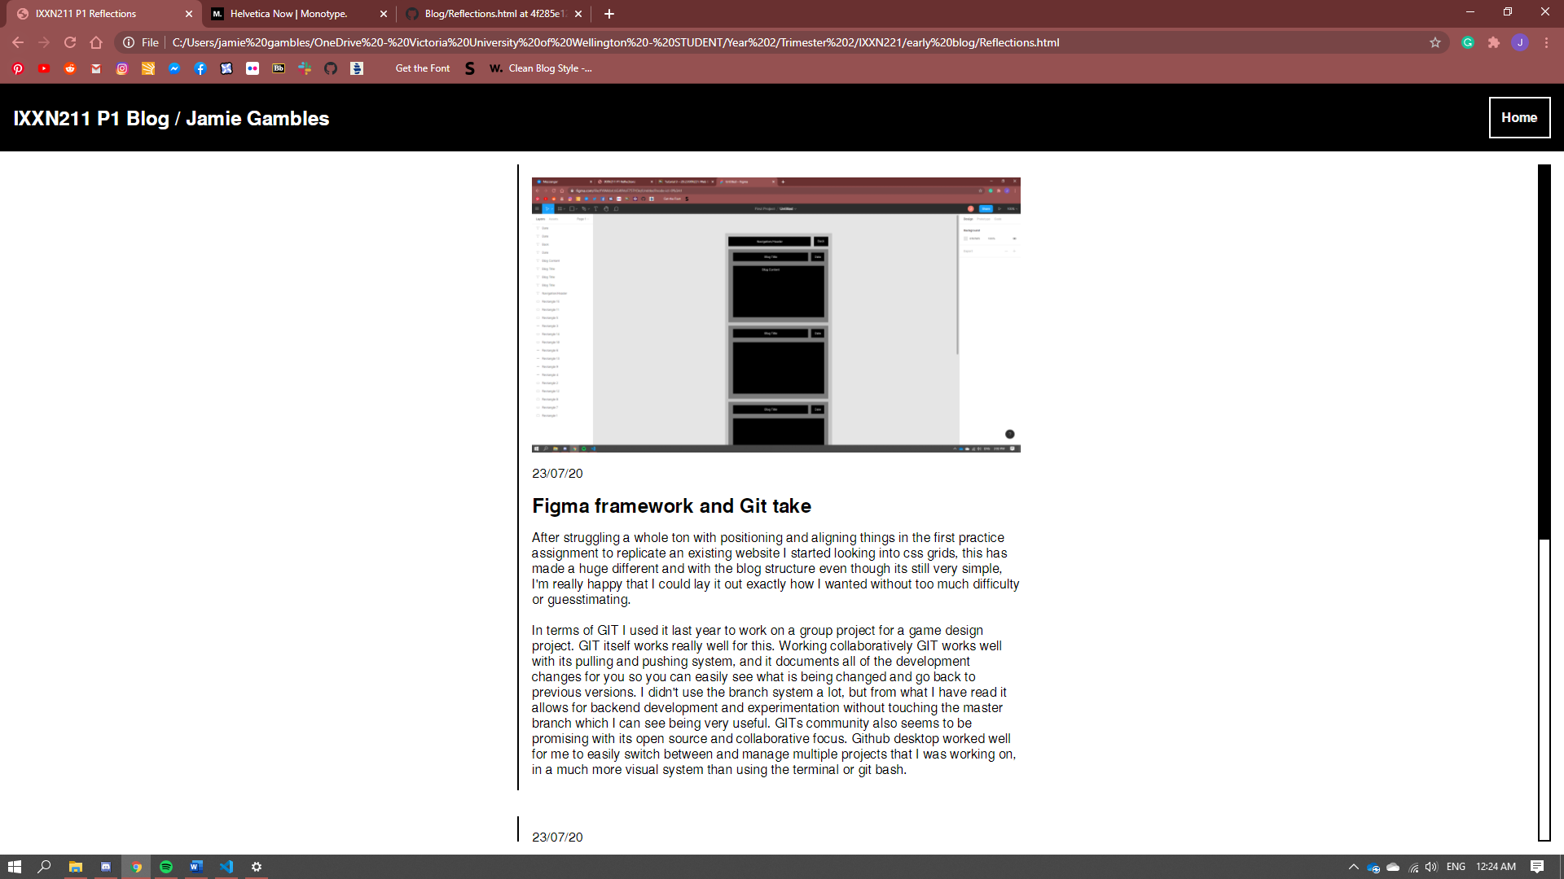

* After working on the structure of my blog yesterday I started looking at the styling of the whole page, as well as the structure of each blog post. With my current layout of a lot of nested divs each with their own padding I was wasting a lot of space. I decided to remove the colour from each of the different div, so that a smaller margin was less jarring, I then gave each element its own div as opposed to nesting all of the 'content' together. This way I can freely reorder how the information is stacked. I also changed from using the grid system to center and scale the blog posts proportionally, as when using fractions, the blogs would become too thin when the browser was rescaled. I changed to instead using a min and max width, and then a margin on the sides of the scrollbar div. This is so that the blogs will stay at a constant size when being scaled, until the margin pushes them closer together.  
    
  Style wise I changed from my boxy appearance as that was really just there to see the margins for each div. I'm a fan of minimalist websites so I went for an incredibly boring theme of black and white, using the font Helvetica. I restyled the scrollbar to match this aesthetic and added a single line border on each blog post to easily differentiate between blog posts.

25/07/20 – Saturday

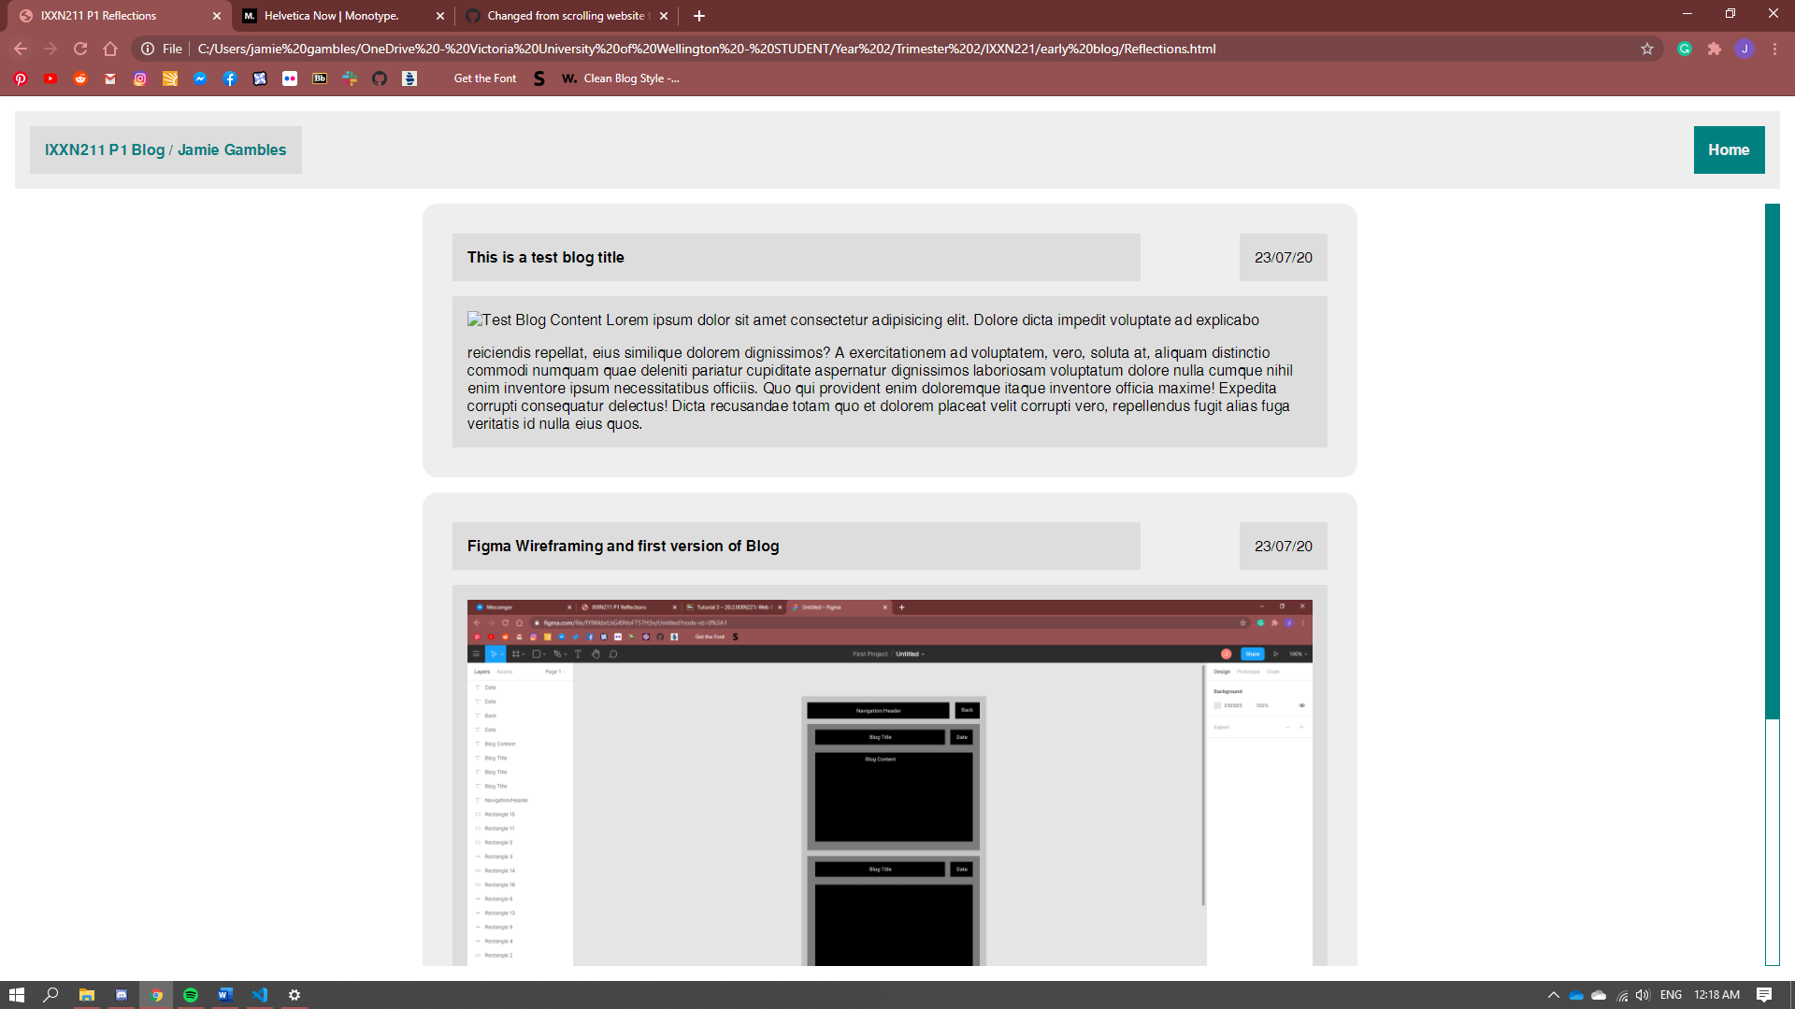

* Worked a lot more on the structure of blog itself, I had a rough idea of what I wanted to do, such as the best way to implement the stickied header at the top. I disliked the regular way of achieving this of just giving the header a stickied position because I wanted the header in both the home page and reflections page to be inline, however with more posts the reflections page had a scrollbar and the home didn't, causing them to be out of line.  
    
  The way I ended up getting around this was actually setting the wrapper div to be the exact viewport size, so that a scrollbar is not generated. And then wrapping the blog posts within another div, this time with overflow, this meant that the header stayed constant and I could still scroll through the blogs nicely, this also meant that the scrollbar was now nicely offset from the side of the page, and I can place it neatly in-line with the header with a consistent margin.  
    
  After achieving this I started looking at the styling of the whole page, as well as the structure of each blog post. With my current layout of a lot of nested divs each with their own padding I was wasting a lot of space. I decided to remove the colour from each of the different div, so that a smaller margin was less jarring, I then gave each element its own div as opposed to nesting all of the 'content' together. This way I can freely reorder how the information is stacked. I also changed from using the grid system to center and scale the blog posts proportionally, as when using fractions, the blogs would become too thin when the browser was rescaled. I changed to instead using a min and max width, and then a margin on the sides of the scrollbar div. This is so that the blogs will stay at a constant size when being scaled, until the margin pushes them closer together.  
    
  Style wise I changed from my boxy appearance as that was really just there to see the margins for each div. I'm a fan of minimalist website so I went for an incredibly boring theme of black and white, using the font Helvetica. I restyled the scrollbar to match this aesthetic and added a single line border on each blog post to easily differentiate between blog posts.

23/07/20 – Thursday

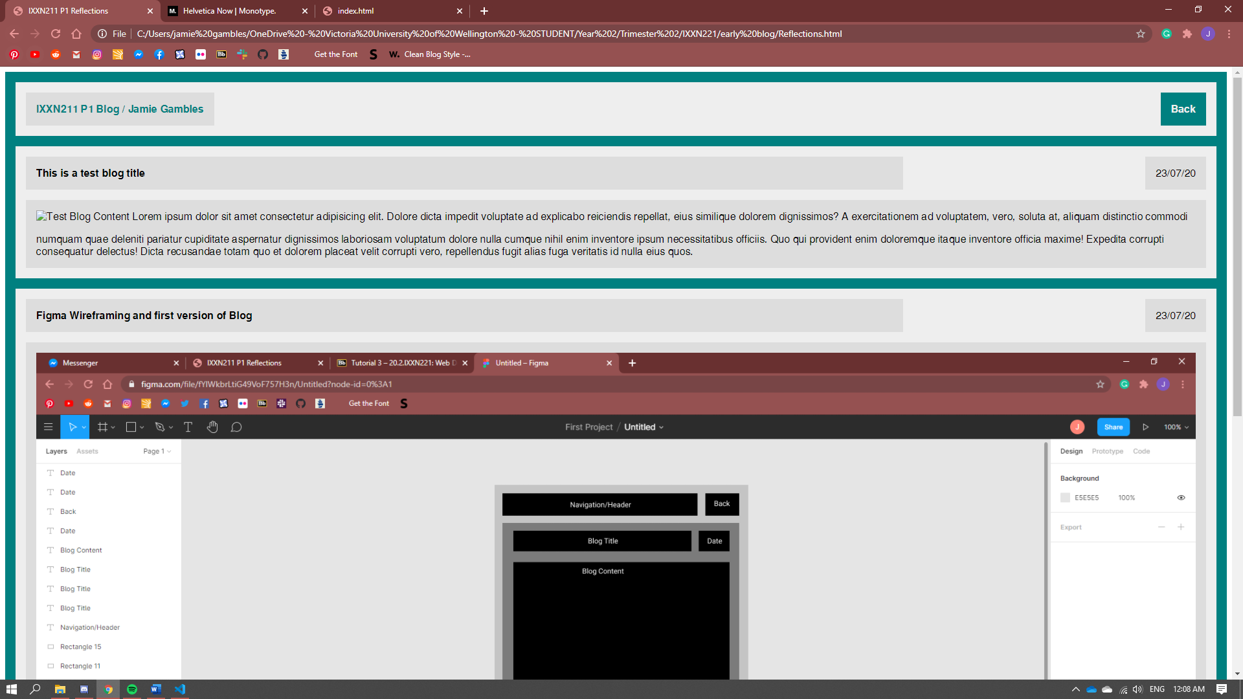

* We went over some basic CSS practices today and got introduced to project 1. I also set up my github for this project. Today I put more time into my blog, this time I looked at adding a navbar to the reflections page so that you can move back and forth between the two pages. I also started looking at the formatting of images in blog posts, and on hover effects for the button using CSS

21/07/20 – Tuesday

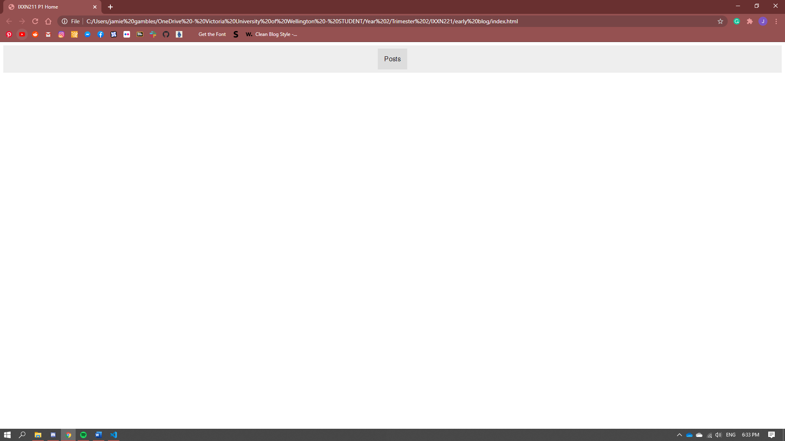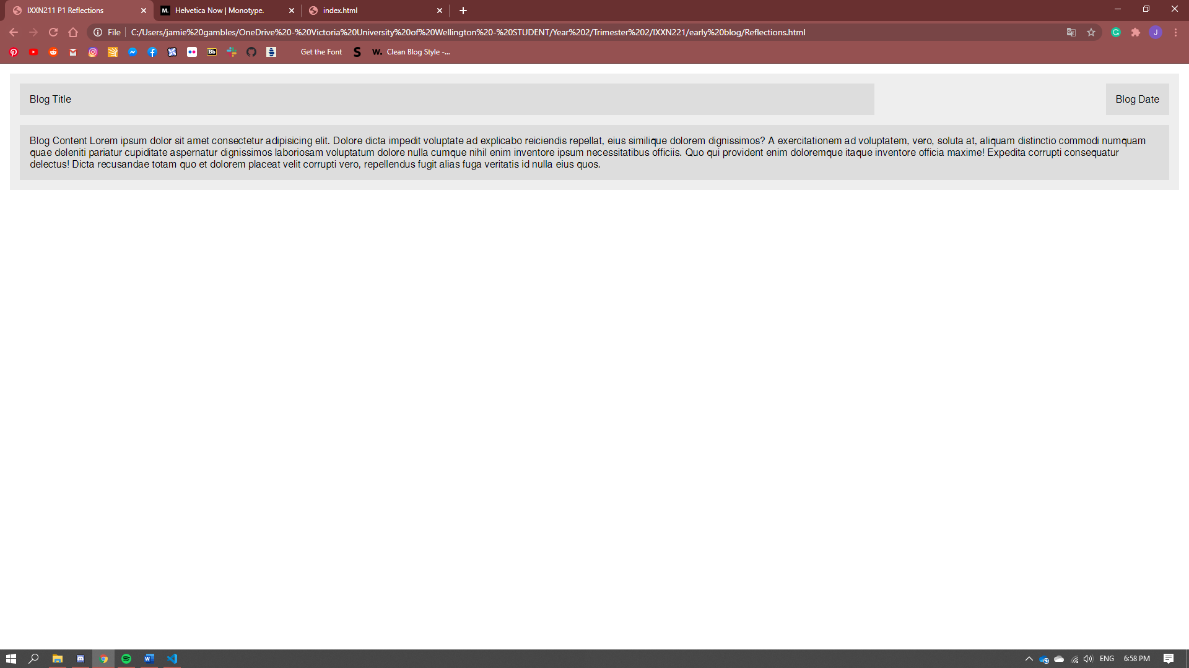

* Spent the class time constructing my blog. After struggling a ton with simply aligning things vertically in our first mini assignment to replicate an existing website josh had told me that I should be using CSS Grids. I used these in my mock-up for my blog as more of a proof of concept, but I ended up really liking it. Grids work fantastically and made the whole experience a lot more enjoyable for me as I enjoy a highly structured system to worth within. With this early version of my blog I am not too worried about styling as I can always come back to that, I am more focussed on creating a layout for the content that makes sense and is easy to navigate. Here is the first iteration of the home page and reflections page that I created, the home page is very simple because I’m really not too sure on what I need to have on there so at the moment it just has the button that links you to the reflections page. The reflections page is very simple as well, just containing a singular ‘card’ layout for a single post.

16/07/20 – Thursday

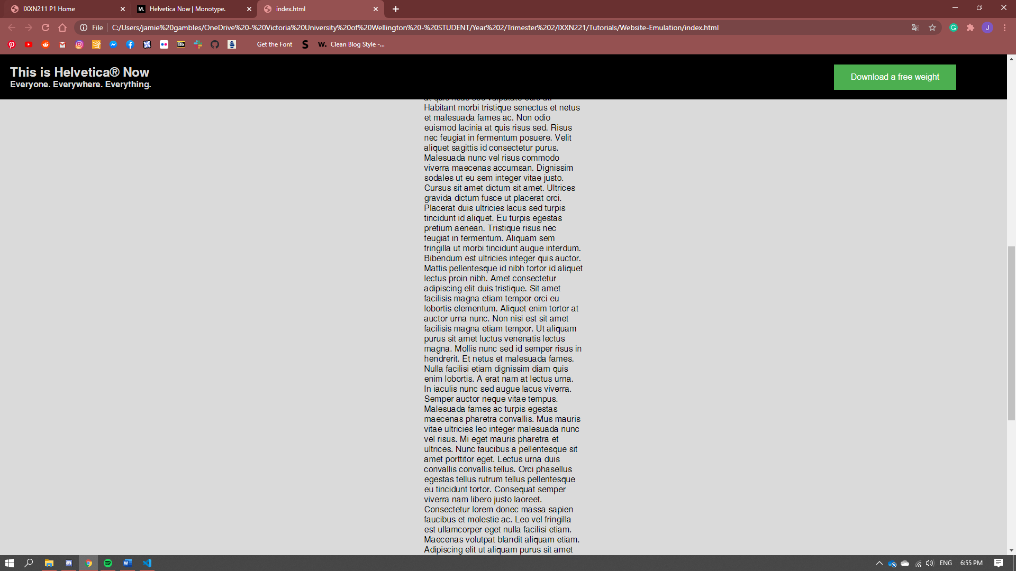

* We looked at the CSS ‘box model’ today and worked further on our small assignment to replicate a part of existing website. I chose the stickied navigation bar thing from the Helvetica Now website. I really struggled with emulating this because I couldn’t figure out how to correctly vertically centre text within a div without just estimating it with padding and margins because if I did that then the website would not be responsive. This is as far as I got, the biggest cause of my issues was that I needed the header and subheader within the navbar thing to be in different divs so that they could be different font sizes, but then this meant having to centre to divs proportionately to the centre of another which I couldn’t figure out.

14/07/20 – Tuesday

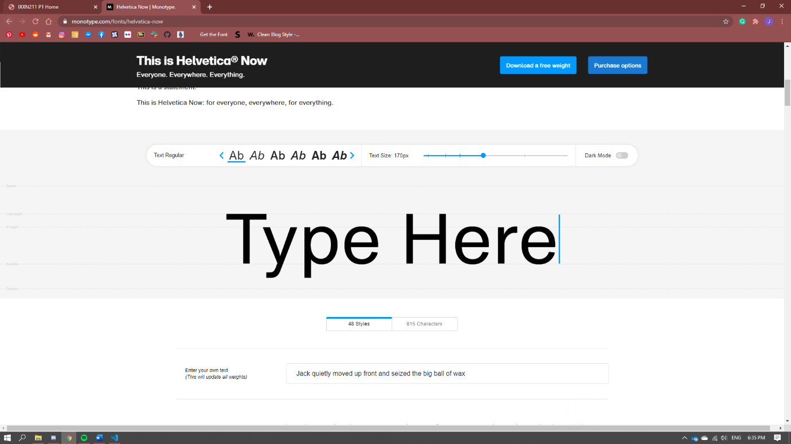

* First class, we got introduced to HTML and CSS quickly and then given a mini assignment to replicate an existing website. I chose to do the Helvetica Now Website from Monotype here <https://www.monotype.com/fonts/helvetica-now>